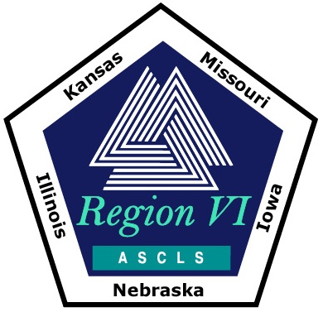
RHO SIGMA DISTINGUISHED SERVICE AWARD

Please turn in form before June 1
to Kim Von Ahsen at kim.vonahsen@ascls-ia.org

NOMINATION FORM

Nominee Qualifications:
- Region VI member (Elected officers and the Regional Director are ineligible.)
- Responsible for significant contributions benefiting Region VI directly.

(To be completed by the Nominator)

I wish to nominate

Contributions the nominee has made to Region VI include:

Nominator’s Name:

Date submitted:

