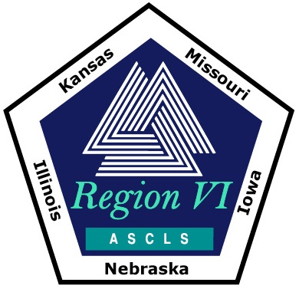
RHO SIGMA DISTINGUISHED SERVICE AWARD

Please turn in form before June 15
to Kim Von Ahsen at secretary@ascls-regionvi.org

CANDIDATE INORMATION FORM

(To be completed by the Nominee)

NAME:

ASCLS #:

ADDRESS:

CITY: STATE: ZIP CODE:

REGIONAL ACTIVITIES/ACCOMPLISHMENTS:

Do you plan on attending the National ASCLS Annual Conference in Chicago, IL and the Region VI Rho Sigma Dinner? Yes No

Date submitted:

